Project No.C10

Virtual Keyboard by Leap Motion

Presented by
1. Mr. Phuwadon Verasertniyom 56070503426
2. Mr Sarun Kongsungnern 56070503433
3.Mr. Siwat Karwlung 56070503434

Advisor

Asst. Prof. Songrit Maneewongvatana, Ph.D.

“I’ve read and approved the content of this report”

………………………………………….
(…………………………………………)
Advisor

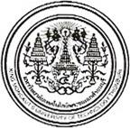

Virtual Keyboard by Leap Motion

1. Mr. Phuwadon Verasertniyom 56070503426
2. Mr Sarun Kongsungnern 56070503433
3.Mr. Siwat Karwlung 506070503434

A Project Submitted in Partial Fulfillment of the Requirements
for the Degree of Bachelor of Engineering
Department of Computer Engineering, Faculty of Engineering
King Mongkut’s University of Technology Thonburi
Academic Year 2013

Virtual Keyboard by Leap Motion

1. Mr. Phuwadon Verasertniyom 56070503426
2. Mr Sarun Kongsungnern 56070503433
3.Mr. Siwat Karwlung 506070503434

A Project Submitted in Partial Fulfillment of the Requirements
for the Degree of Bachelor of Engineering
Department of Computer Engineering, Faculty of Engineering
King Mongkut’s University of Technology Thonburi
Academic Year 2013

Project Committee

…………………………………………………………… Chairman
(Assoc. Prof. Suthep Madarasmi, Ph.D.)

…………………………………………………………… Committee
(Asst. Prof. Songrit Maneewongvatana, Ph.D.)

…………………………………………………………… Committee
(Asst. Prof. Peerapon Siripongwutikorn, Ph.D.)

Project Title Virtual keyboard by leap motion
Project Credit 7 credits
Project Participant 1. Mr. Phuwadon Verasertniyom 56070503426
2. Mr Sarun Kongsungnern 56070503433
3.Mr. Siwat Karwlung 506070503434
Advisor Asst. Prof. Songrit Maneewongvatana, Ph.D.
Degree of Study Bachelor's Degree
Department Computer Engineering
Academic Year 2013

Abstract

This project studies the concepts of leap motion and Java application. In past, even though keyboard developed to be smaller. But it is not expediently to contain. And now we have a more new technology especially smart phones and tablet. And we have a problem about carry keyboard. Leap motion is infrared sensor and input device of computer which acting like mouse. It have infrared sensor and detect hand, finger and palm. We will create keyboard for easy to carry by leap motion.
We use Java application to created virtual keyboard GUI. Program will receive values in 3 axis from leap motion with X axis and Z axis is a position of your hand. And Y axis is a level of finger for press a virtual keyboard.
We tried to use Eclipse but, it hard to work. Finally, we use Java application for created virtual keyboard GUI by Netbeans. It is better than Eclipse.

Acknowledgement

We would like to express our appreciation for all the helps and supports that we had received while working on this project. We couldn’t complete this project without the help of our teacher assistance, Mr. Chattriya Jariyavajee. He shared his time to guideline us for every week helping our project ran smoothly. We are very pleased to thank him very much here.
We also appreciated for our project room and the computer center server room. Every instructor that has given us knowledge and this is where our project started. Finally, we would like to thank every committee to guide us in the project examinations.

Contents

Page
Chapter 1 Introduction 1
1.1 Problem Statement and Approach 1
1.2 Objective 1
1.3 Scope 1
1.4 Tasks and schedule 2
Chapter 2 Background, Theory and Related Research 3
2.1 Leap Motion Controller 3 2.2 Programming language : Java 3
2.3 Eclipse 4
2.4 Netbeans 5
Chapter 3 Design and Methodology 6
3.1 Hardware & Software requirement 6
3.2 Program Features 6
3.3 Flowchart & Program Functionality 7
3.4 User Interface 7
Chapter 4 Result and Discussion 9
4.1 Screenshots And Explanation 9
4.2 Problems Encountered & Solution 11
Chapter 5 Conclusion 13
5.1 Conclusion 13
5.2 Problem and Solution 13
Reference 14
Appendix 15
A 16

List of Figures

Figure Page
2.1 Leap Motion 3
2.2 Java Logo 4
2.3 Eclipse 5
2.4 Netbeans 5
3.2 Leapmotion 6
3.3 flowchart 7
3.4.1 User Inerface1 7
3.4.2 User Inerface2 8
3.4.3 User Inerface3 8
4.1.1 program1 9
4.1.2 program2 9
4.1.3 program3 10
4.1.4 program4 10
4.2.1 concept1 11
4.2.2 concept2 11
4.2.3 concept3 12

List of Tables

Table Page
1.1 Tasks and schedule 2

Chapter 1

Introduction
  - Problem Statement and Approach
At the beginning, we have interested about new technology. Which it may be change daily life. Then we found infrared sensor device in advertise. It called “Leap Motion”. The Leap Motion Controller is designed and optimized to detect and track hands, fingers and finger-like tools. The device’s field of view extends from approximately 25 to 600 millimeters above the device.
  - Objective
- To created Virtual Keyboard GUI to use in Leap Motion for make lifestyle more convenient.
- To study processing of Leap Motion.
- To study Java.

1.3 Scope
- Make the program that can use instead of keyboard by Leap Motion.
- The position of hand depend on Z axis and X axis.
- The button will press depend on Y axis.
- This program is written in Java.

1.4 Tasks and schedule

Task & Procedure | September |  |  |  | October |  |  |  | November |  |  |  | December
Task & Procedure | W 1 | W 2 | W 3 | W 4 | W 1 | W 2 | W 3 | W 4 | W 1 | W 2 | W 3 | W 4 | W 1 | W 2 | W 3
1. Planning
- Selecting topic
- Brainstorming
- Exchanging Information
2. Features
- Program purpose
- What can it do?
- Scope
3. Collecting necessary data
- Gathering info from the Internet
- Asking professors or TAs
- Finding references from library
4. Basic User Interface Design
- Decide input method
- Decide output method
- Design basic appearance
5. Programming
- Platform
- Program to use
- Writing a program
6. Testing and Finalizing program
- Debugging
- Checking data
- Finalize program appearance

Remark: This schedule contains some procedures information of each task to demonstrate as brief examples.

Chapter 2

Background, Theory and Related Research

2.1 Leap Motion Controller
Leap Motion, Inc. is an American company that manufactures and markets a computer hardware sensor device that supports hand and finger motions as input, analogous to a mouse, but requiring no hand contact or touching.
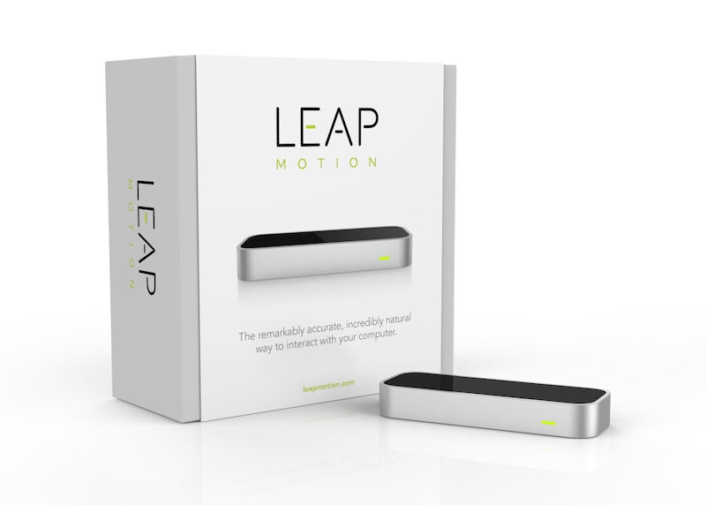
Figure 2.1 Leap Motion

2.2 Programming language : Java
Java is a programming language and computing platform first released by Sun
Microsystems in 1995. There are lots of applications and websites that will not work unless you have Java installed, and more are created every day. Java is fast, secure, and reliable. From laptops to datacenters, game consoles to scientific supercomputers, cell phones to the Internet, Java is everywhere!

Figure 2.2 Java Logo
2.3 Eclipse
Eclipse is a platform that has been designed from the ground up for building integrated web and application development tooling. By design, the platform does not provide a great deal of end user functionality by itself. The value of the platform is what it encourages: rapid development of integrated features based on a plug-in model.
Eclipse provides a common user interface (UI) model for working with tools. It is designed to run on multiple operating systems while providing robust integration with each underlying OS. Plug-ins can program to the Eclipse portable APIs and run unchanged on any of the supported operating systems.
At the core of Eclipse is an architecture for dynamic discovery, loading, and running of plug-ins. The platform handles the logistics of finding and running the right code. The platform UI provides a standard user navigation model. Each plug-in can then focus on doing a small number of tasks well. What kinds of tasks? Defining, testing, animating, publishing, compiling, debugging, diagramming...the only limit is your imagination.We use Eclipse for writing program.
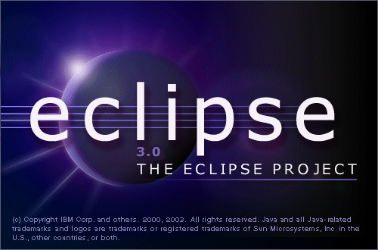
Figure 2.3 Eclipse

2.4 Netbeans
NetBeans is an open-source integrated development environment (IDE) for developing with Java, PHP, C++, and other programming languages. NetBeans is also referred to as a platform of modular components used for developing Java desktop applications. We use Netbeans for created GUI.



Figure 2.4 Netbeans

Chapter 3

Design and Methodology

3.1 Hardware & Software requirement
- A computer running all OS (Windows, Mac and Linux)
- USB 2.0 Port
- Internet Connection
- Java SE Runtime Environment 7
- Airspace
- Driver of Leap Motion can find in official wedsite

3.2 Program Features
Virtual keyboard is to provide an alternative input mechanism for users with disabilities who do not want to use a physical keyboard. It will help user for easy to contain keyboard.
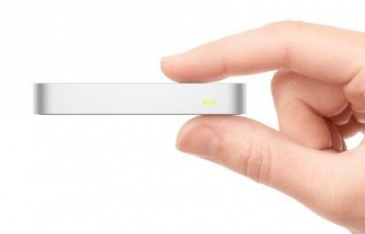
Figure 3.2 Leap motion

3.3 Flowchart & Program Functionality
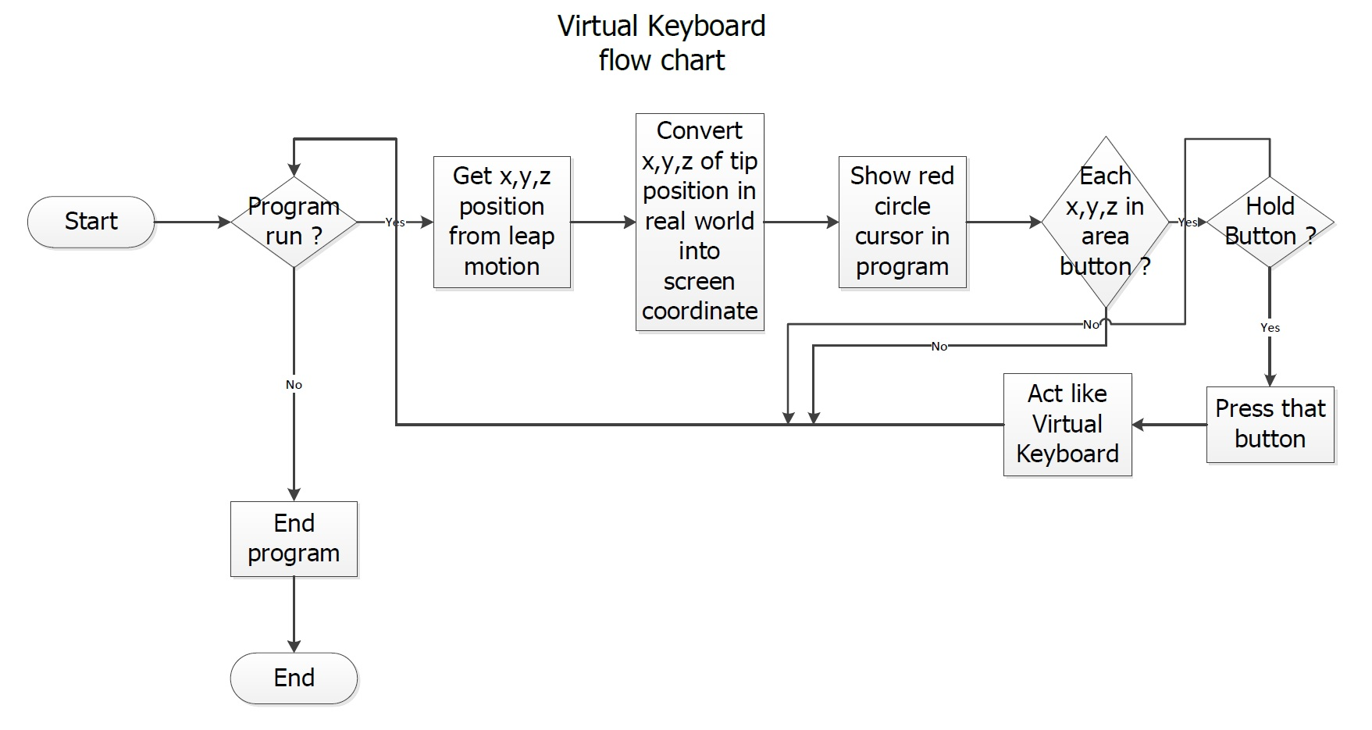

Figure 3.3 flowchart

3.4 User Interface

This picture below is show about user interface.
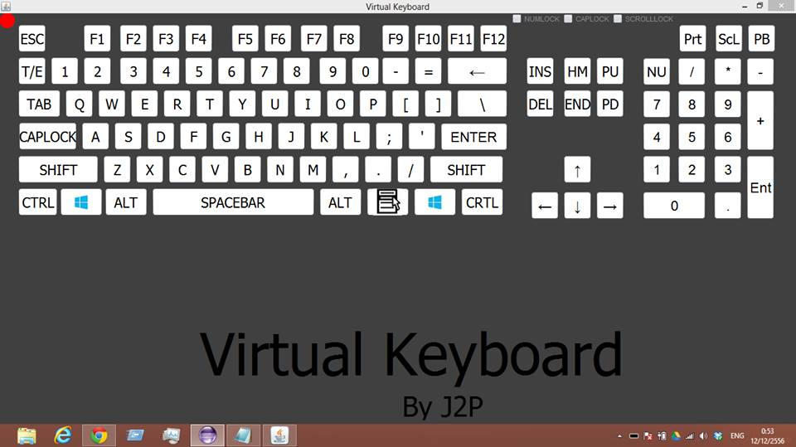
Figure 3.4.1 User Inerface1

You can see cursor which show position of your finger.
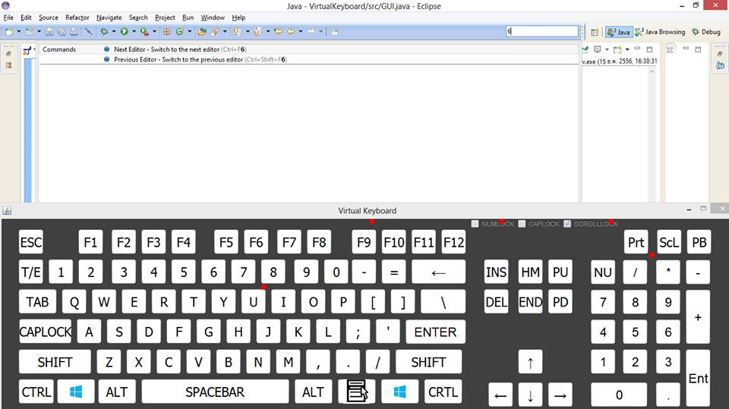
Figure 3.4.2 User Inerface2

You can press the button.
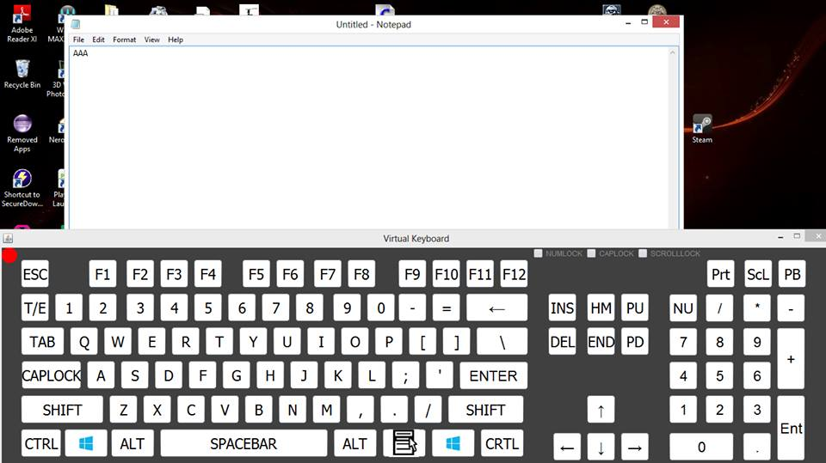
Figure3.4.1 User Inerface3

Chapter 4

Result and Discussion

4.1 Screenshots And Explanation

This picture below is show about interface program.

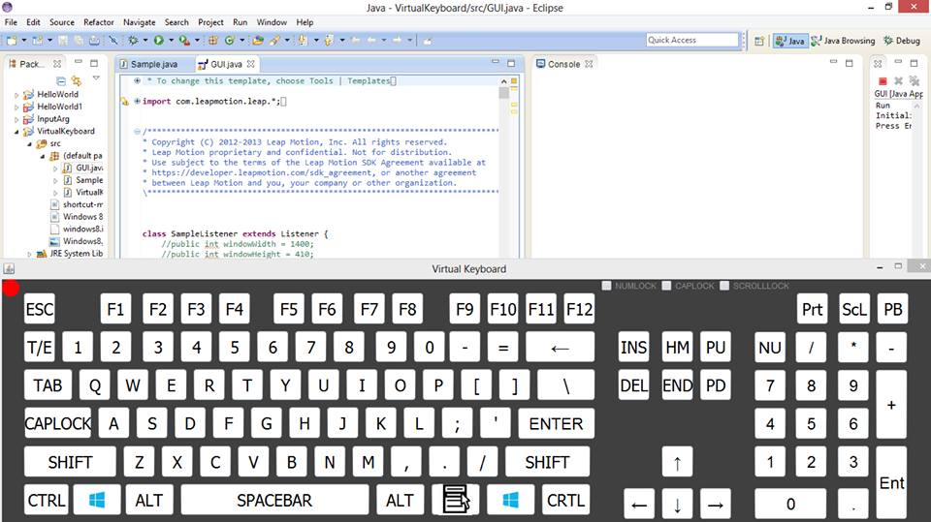
Figure 4.1.1 program1
You can press button by your finger.
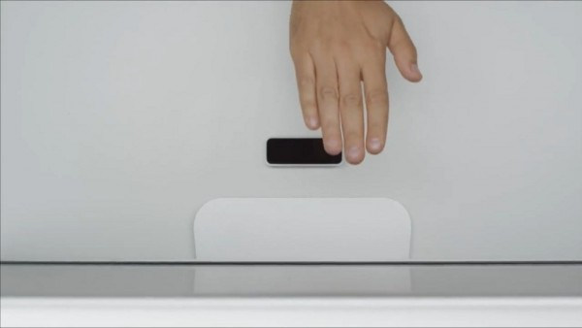
Figure 4.1.2 program2
Cursor will show position of your finger.

Figure 4.1.3 program3
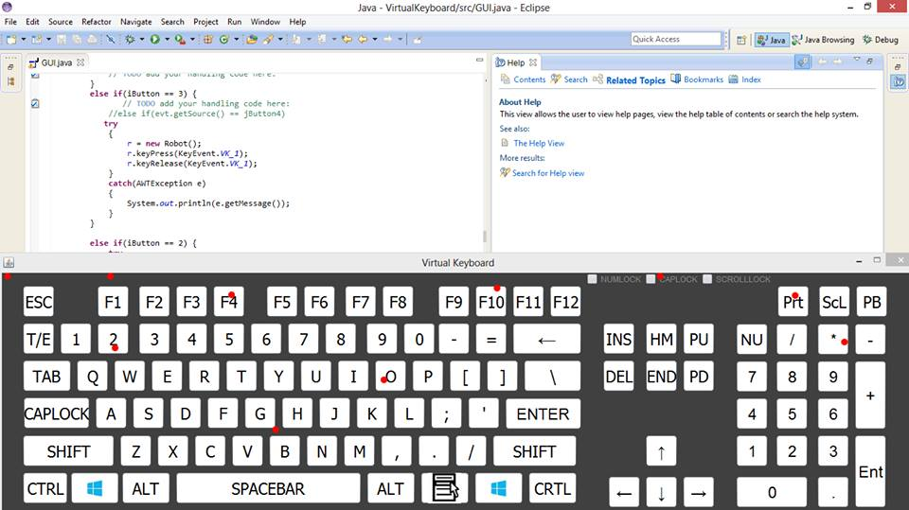
Figure 4.1.4 program4

4.2 Problems Encountered & Solution
We found the problem in first draft concept below because we cannot change axis of Leap Motion. Leap motion cannot detect on backhand .And we do not have driver in smart phones.

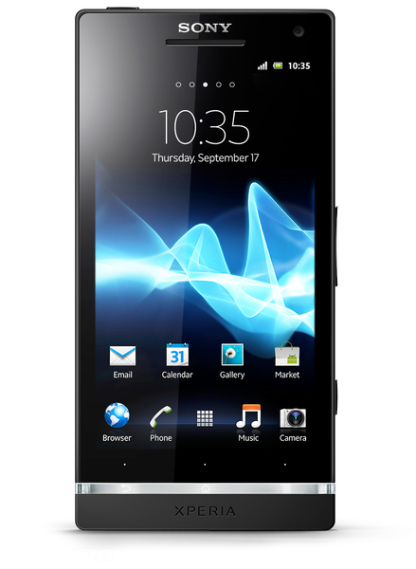
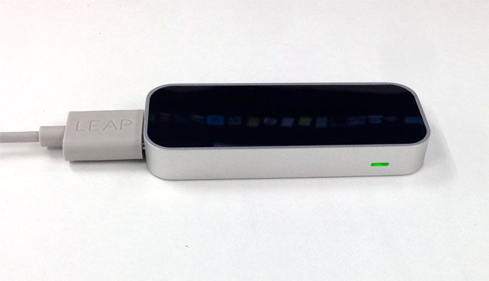

Figure 4.2.1 concept1
So, we change to the next concept below. But we found the problem again. In this concept we used acrylic for base of Virtual keyboard. It will comfortable for user. But, it is hard to contain.
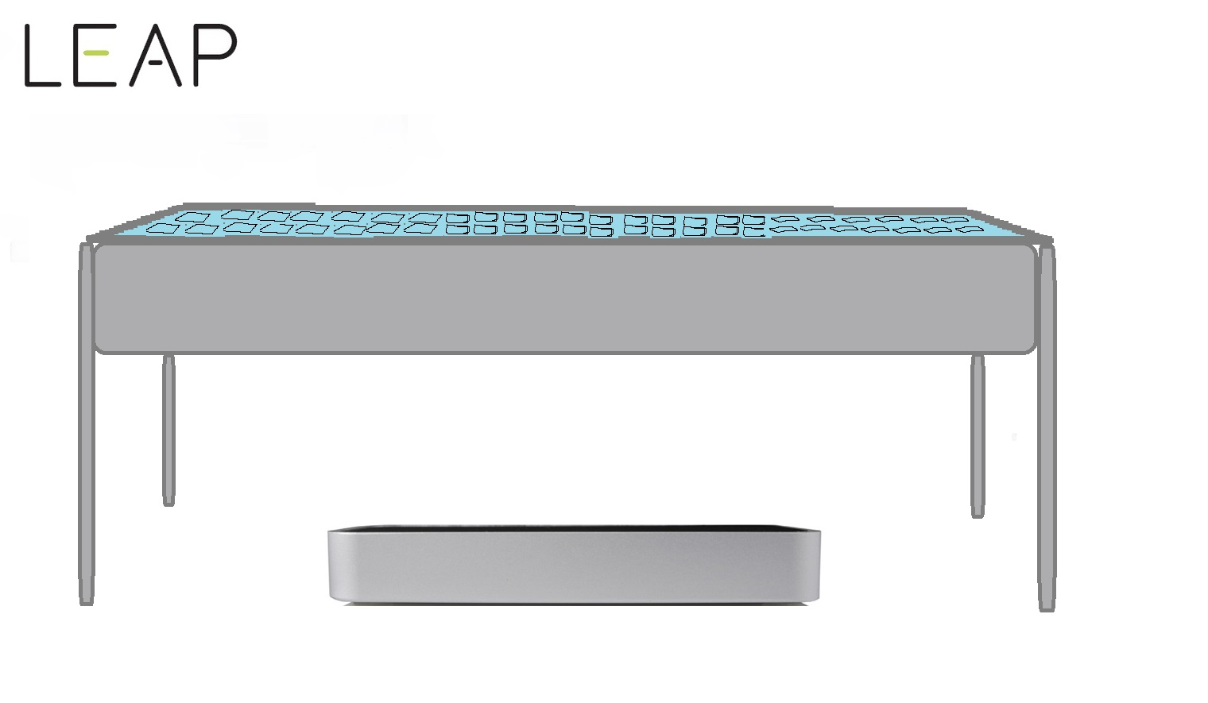
Figure 4.2.2 concept2
Finally, we do not need to use any equipment in last concept.
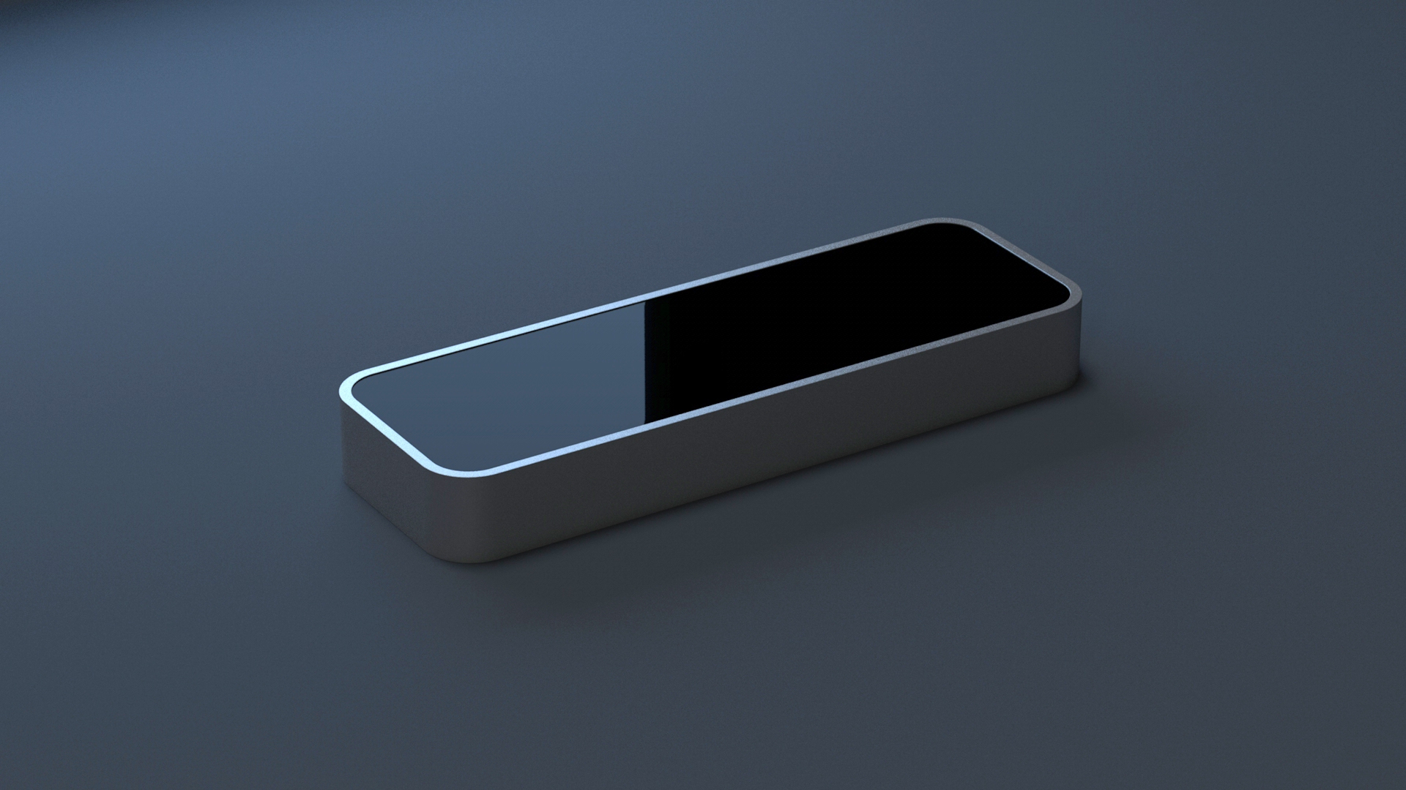

Figure 4.2.3 concept3

Chapter 5

Conclusion

5.1 Conclusion
User can press all button. This program cannot show button such as Cap Lock or Num Lock. But program can run and use same psychical keyboard. But it is not smooth. When user move finger to stick together. Leap motion will detect combination. Because leap motion is not good enough.

5.2 Problem and Solution
We cannot use this program smoothly. And we cannot solve this problem.
Because leap motion is not good enough.

References

- Leap Motion Controller, 2010, http://en.wikipedia.org/wiki/Leap_Motion
- Java, 2013, http://www.java.com/en/download/faq/whatis_java.xml
- Eclipes,2013,http://help.eclipse.org/kepler/index.jsp?topic=%2Forg.eclipse.platform.doc.isv%2Fguide%2Fint_eclipse.htm
- Netbean, 2010, http://www.techopedia.com/definition/24735/netbeans

Appendix
Appendix A

We test acrylic. That sensor of leap motion can detect past acrylic.
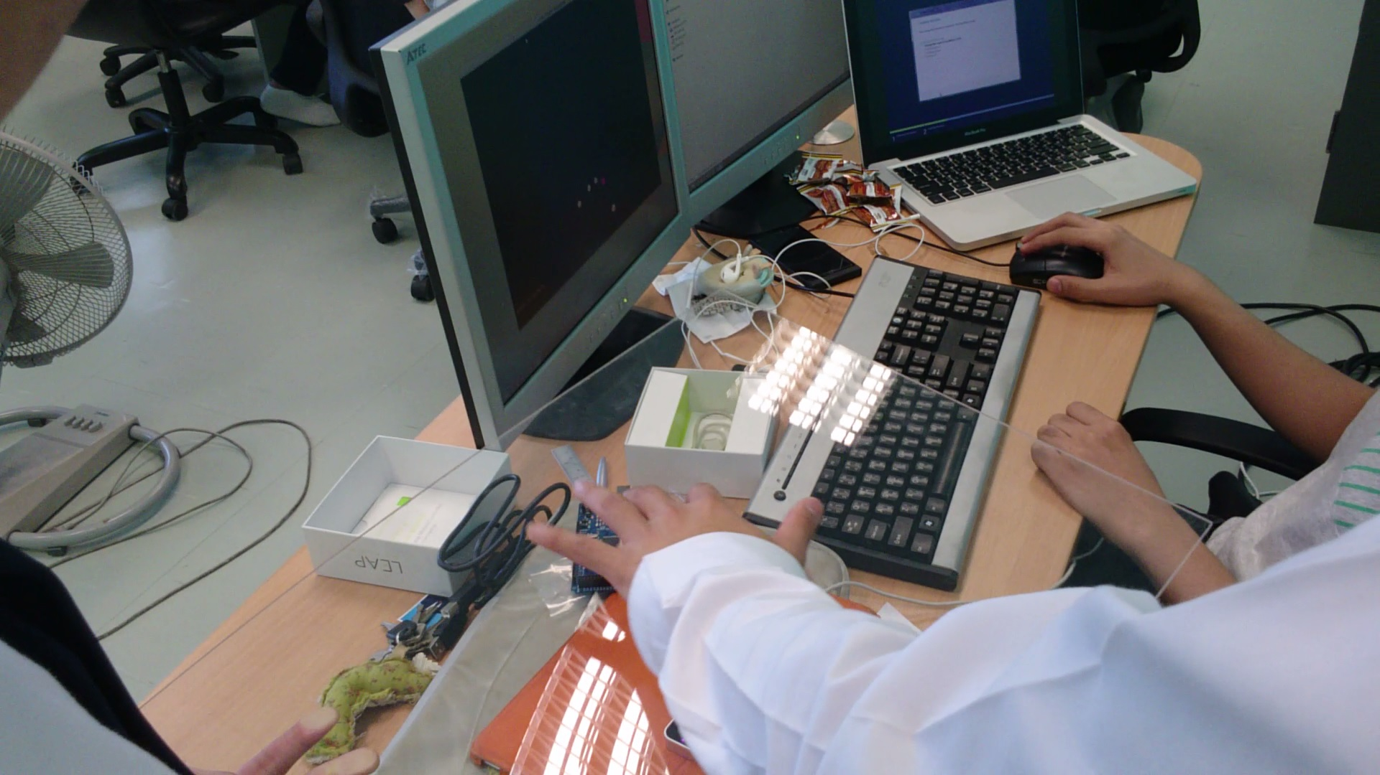

Figure A.1 test1

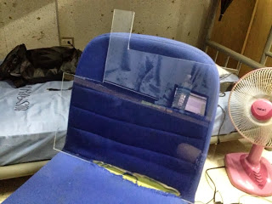
Figure A.2 Equipment

